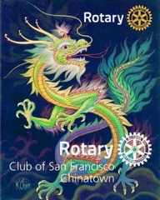
Rotary Club of SF Chinatown
Newsletter
March 2021 vol #9

Welcome members and friends to our Club’s March Newsletter.

Our RCSFC Fundraising Results February 20th 2021
This is the Year of the Ox.
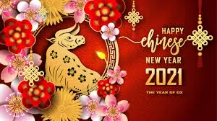

The 2021 RCSFC Foundation Fundraiser Raffle Raised:
$20,000
WOW!!!!
Thank you one and all for making this event so very successful. Your generosity will help to fund scholarships, and the vast local and international programs that we support, helping those less fortunate and marginalized.
Our Winners:
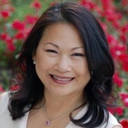
Cash Prize: $2021 Lily Chan

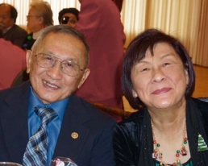
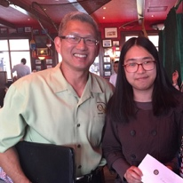
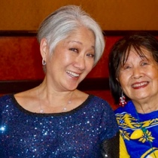
Cash Prize $1000 Ted and Helen Abe

Cash Prize $500 Jennifer & Richard Cheung

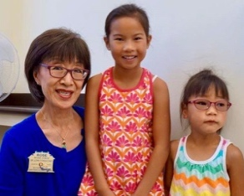
Lily’s Flower Arrangement : Kara Luong (Rose Chew’s Granddaughter)

Petaluma River Cruise and Lunch : Sofia Luong (Rose Chew’s Granddaughter)

1
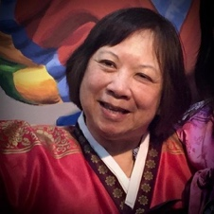

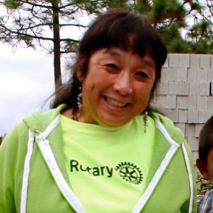
Gift Basket #1 Pauline Chin
Gift Basket #2 Arleen Kwan
Gift Basket #3 Pauline Ancell

Summary of Past February Events:
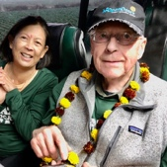
.

February 3rd Club Meeting & Brief Memorial for Edward Pierce

February 17th Club Meeting Guest : Jon Kaufman –
Building Self Reliance through H2Open Doors

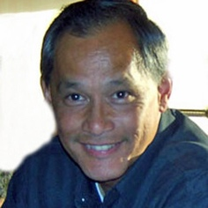
March 3rd Club Meeting
Guest: Russell Low MD author of “Three Coins”
Purchase his book @ rlow52@yahoo.com for an autographed copy)

Upcoming Events

See Our Club Website:
https://www.sfchinatownrotary.org/weekly-program-speakers
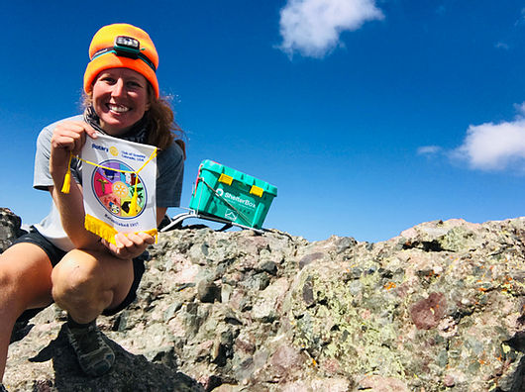
March 17th Club Meeting Guest: Brittney Woodrum
“Hiking 28 peaks in Colorado for Shelter Box”
Special visit by PDG Jayne Hulbert. She will award Paul Harris
Fellows to our club members.

2

Elections for 2021-22 Officer Positions
(Effective July 1st 2021)
RCSFC Operational Board
President: Richard Swart
Past President: Paul Chin (PP)
President Elect: Rhonda Pierce (PE)
Secretary: Liz Mark
Treasurer: Reagan Lee
(July 1st We want to thank Clifford Cheung for his prior services as Treasurer)

4 Directors: Jennifer Cheung, Gary Watts, Celine Wong, Tami Aviles
(July 1st We want to thank Judy Judkins and Vanita Louie for their prior services as Board Directors.)

RCSFC Foundation Board
(We will have all the same presidential line as above)
Secretary: Junko Low
Treasurer: Cathy Cheung

2 Directors: Stu Williams, Lily Chan

Our Incredible Club Members meeting 2x month on Zoom Platform
1st and 3rd Wednesdays of each month. 12 – 1:30pm
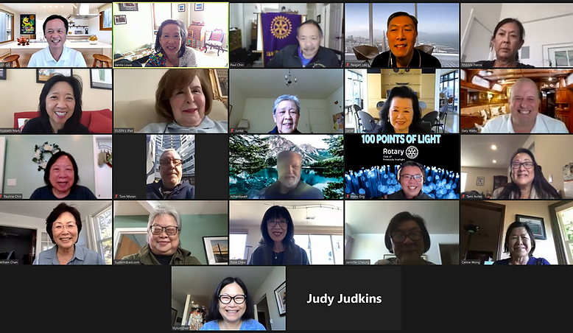

3

Chinatown News: (Feb 14th 2021 )
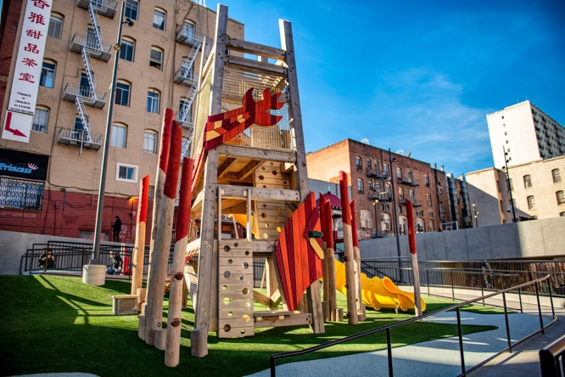
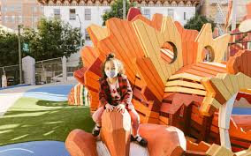
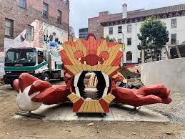
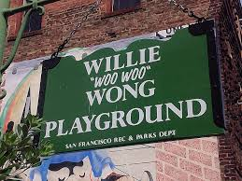
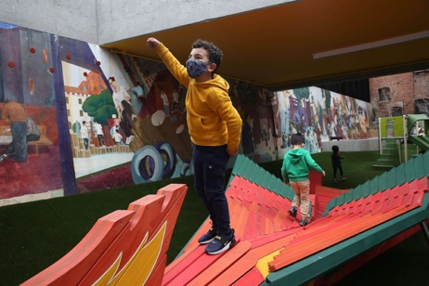
San Francisco reopened the Willie ‘Woo Woo’ Wong Playground and Clubhouse in the heart of Chinatown just in time for the Lunar New Year. This two year, $15 million renovation, features custom designed play equipment inspired by Chinese mythology, including a water dragon and phoenix sculpture. The community center will provide 12 students with in-person support for distance learning, healthy food and recreation opportunities. Formerly called Chinese Playground, the park opened in 1927, with swings and slides and a sports court. It was last renovated in 1980. It was later renamed in 2006 to honor Willie Wong, a Chinese American basketball player who played for University of SF from 1948-50. Wong earned his nickname due to crowds shouting “Woo! Woo!” every time he scored. The dragon is the centerpiece of this park/community center hybrid. A three story indoor-outdoor structure is replete with climbing structures, outdoor exercise equipment, volleyball, pickleball/basketball courts and a community gathering room. All packed into the challenging confines of a half acre. “This is a Big Day for the Chinatown Community”, said Sarah Wan, Executive Director of CYC (Community Youth Center). “We are excited to provide a safe and stable learning space for the youth in Chinatown that need it the most.” “Everyone was thrilled that the playground opened just in time to welcome The Year of the Ox!” Restaurateur Bill Lee, whose Far East Café is a block away, said “all that exercising is bound to make park goers hungry.” And he predicts an uptick in business in the months ahead.

4
March Birthdays

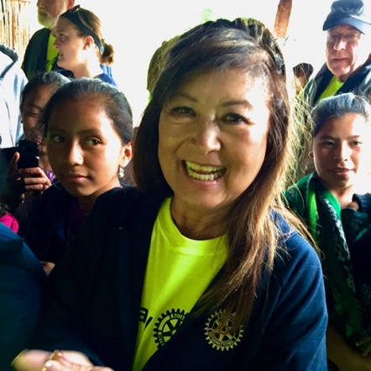

Carol Jue Happy Birthday Carol!!

March’s Rotary Theme
is:
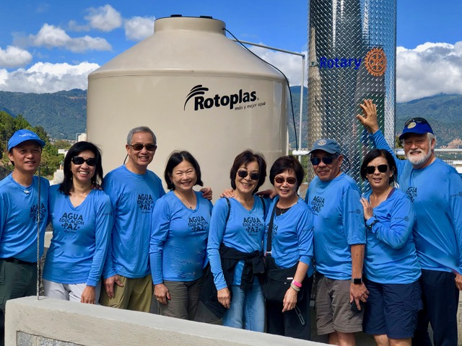
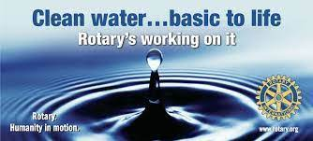
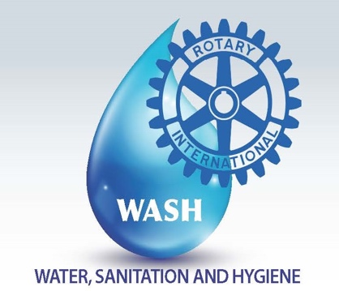
Water and Sanitation Month
Our Club with H2OpenDoors Water Instillation Jan 2020

5

February 12th Begins the Celebration of Chinese Lunar New Year
The Year of the Ox
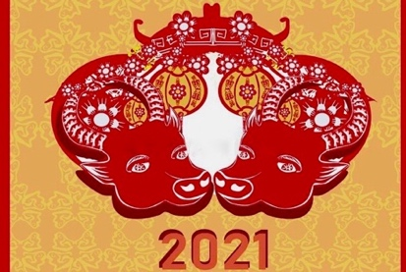
It is also appropriate as it is the “Year of Vaccinations”!!! The term Vaccination comes from Vaca (Cow or Ox) as the first vaccination was using “cow pox” inoculations to successfully prevent “small pox” in humans.

February 12th 2021 marks the beginning of the Year of the Ox, specifically the Metal Ox, coming after the Year of the Metal Rat (2020) and before the Year of the Water Tiger (2022).

The Ox is the second animal of the 12 Chinese Zodiac signs: Rat, Ox, Tiger, Rabbit, Dragon, Snake, Horse, Goat, Monkey, Rooster, Dog and Pig. The Ox year denotes the hard work, positivity and honesty that will be manifested in all of us in the coming 12 months. According to Chinese astrologers, the Ox is very hardworking and methodical. 2021 will be the year when work will be rewarded and the Yin Energy, specific to the sign of the Ox, will be quite poignant as it will be a year when we will fully feel the weight of our responsibilities, a year when it will be necessary to double our efforts to accomplish what we wish. Since this is a Metal year, for the second successive year, the color of 2021 is going to be “white”. Besides white, we have the lucky colors of the Ox (yellow & green), colors that, in Feng Shui, attract prosperity. To increase your luck, wear metal accessories or the colors yellow or green.
This year is Good News: “No explosive or catastrophic events will occur, so it is a favorable year for economic recovery or consolidation, a year of long-term investments…to create a reserve in preparation for leaner times.”
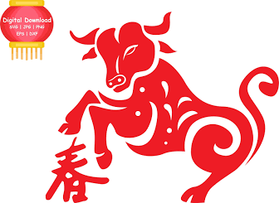
People born in the year of the Ox are strong, reliable, fair and conscientious, inspiring confidence in others. They are calm, patient, methodical and can be trusted. Although they say little, they can be very opinionated and somewhat stubborn.

“Getting to Know You”

As part of the “Getting to Know You” series we have showcased one club member in each Newsletter.
With the Stay in Place (SIP) and Work from Home (WFH) policies being promoted we all suffer from some degree of social isolation. Many of us, though we have met socially for some time, have not had the opportunity to get to know one another better. I initially asked Paul Chin to step up and send me his brief bio with some pictures. Thank you, Paul, for stepping up to get the ball rolling and sharing with our club.
Our July Newsletter showcased Paul Chin his life as a firefighter and his love of family and how he found Rotary
Our August Newsletter we have had the pleasure to get to know our fellow member Celine Wong.
September’s Newsletter shared a brief history of Susan Tom, her growing up in Chinatown,
her teaching career, her family and how they have always supported the Chinatown community.
October we were thankful to have the opportunity to get to know Gayle & Bill Chan, and
learn of their children, their travels and how they found Rotary.
November we followed Eileen O’Riordan’s life journey from her home in Cork, Ireland to
her new adopted home here in San Francisco.
December we all had the privilege to get to know more about our fellow club member, Past President,
our current Assistant Governor and Club Secretary, Liz Mark.
Lily Chan , PP and current Foundation Director was our focus last month.
This month’s Newsletter Honors the Life and Legacy of our very good friend Edward Pierce.
6

This month we are “Getting to Know” and Honor Edward Pierce
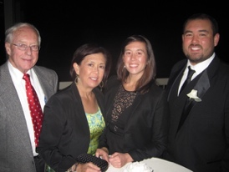
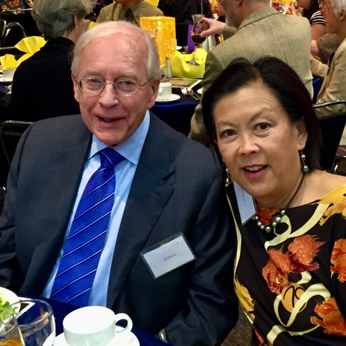
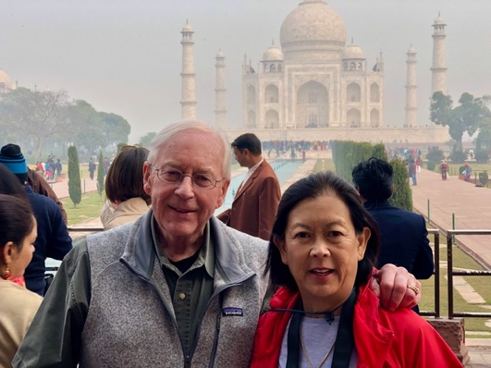
Edward Pierce passed peacefully at home on Jan 30th 2021 at 7:20am under the care of Hospice by the Bay. He left behind his loving wife, Rhonda (of 48 years) and son, Adam; daughter Ashlee; son-in-law Doug; and grandkids Mac, 5, Perry, 3 and Jones, 1. However, he left behind so much more. His legacy of friendships and loved ones and his generous philanthropy had touched deeply the lives of so very many.
Ed had fought a valiant battle this last year combating multiple post-operative infections, an aggressive metastatic lung cancer all while ultimately contracting coronavirus.
Ed, Rhonda, Ashlee & Adam
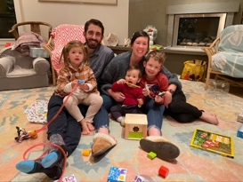
Ed has been described as a man of incredible integrity. Soft-spoken, deeply focused, and meticulously organized, he was a man of action, always motivated to help others and to do what was right and just. His unwavering optimism, love and passion for life and his steadfast service to those less fortunate will stand as both a testament to the man and a legacy of his life.
Doug, Ashlee, Mac, Perry and Jones
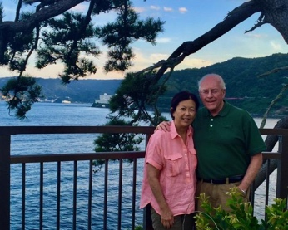
He was born in Rochester, Minnesota in 1941. As an only child at the age of six (6), he moved out to Oregon with his family. As an adult, Ed moved to Sacramento, completed his college education, and was recruited by the I.R.S. While working at the I.R.S., he was stationed in San Francisco, where he was once again recruited by a local public accounting firm. That firm, impressed by his work, hired him soon after he had conducted an audit of one of their clients. He worked at that local firm for a number of years until he joined a much larger national accounting firm. Ed remained in public accounting until the early 90’s. A few years later, he was offered a position as a COO with a manufacturing company, Volk Enterprises, out of Turlock, CA. During the early 2000’s he left Volk to primarily concentrate on real estate investments and management with two (2) other partners and a select group of friends and family.

7

Memorial service will be scheduled in the coming months based on logistics and safety during this pandemic. We collectively mourn his passing and send our love and support for Rhonda, his children and grandchildren. We ask that, in lieu of flowers, a donation be made in his memory, to one of 4 organizations that he supported:

RCSFC Foundation H2OpenDoors
237 Kearny St #381 1160 Industrial Rd #10
San Francisco, CA 94108 San Carlos, CA 94070

SF/Marin Food Bank Hospice by the Bay
2550 Kerner Blvd. 17 E. Sir Francis Drake Blvd.
San Rafael, CA 94901 Larkspur, CA 94939

Be well. Be safe. And may gratitude fill your life.

May the joyful spirit of hope and kindness always dwell deep inside.
May your heart remain full of the love you have for yourself and others. May this time be a time of reflection, gratitude and hope for a brighter day. And may you always be reminded that you are a gift to this world.

Blessings to you all, your families and friends, and those whose lives you touch
through your loving service and generosity.
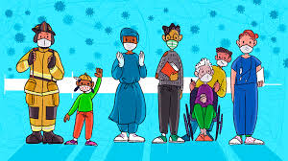
And Remember….Be Safe!
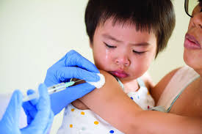
Don't Hesitate to Vaccinate!

8

