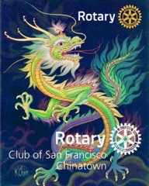
Rotary Club of SF Chinatown
Newsletter
November 2020 vol #5

Welcome members and friends to our Club’s Monthly Newsletter.

RCSFC Fundraising
Paul has expressed strongly that we need to organize and implement a Fundraiser: We have not had a fundraiser in over 2 years. We are currently looking into a “RAFFLE EVENT” for a cash prize of $5150. We will discuss the particulars at our upcoming meetings.

Summary of Past October Events:

October 3rd Polio Summit Event (Virtual)

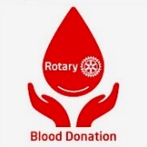
October 9th Rotary Blood Drive

October 15th Annual Westwood – Chinatown Rotary Get Together

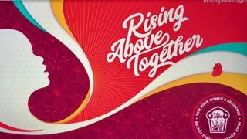
October 17th Gum Moon Annual Gala Rising Above Together

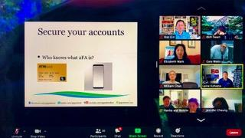
October 21st Club Meeting w Rotarian Laine Kohama
Cyber Security Expert

October 24th Rotary Road Rally an End Polio Now Event
to generate funds for “World End Polio Day”

1
Upcoming Events

See Our Club Website: https://www.sfchinatownrotary.org/weekly-program-speakers

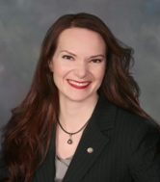
November 13th CCDC SRO Food Packaging and Delivery

November 14th Top Gov Danielle Lallement DGE (Virtual Graduation)
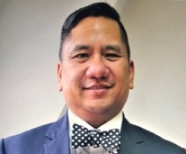
November 18th Club Meeting Speaker: Immigration Attorney

November 21st District Foundation Event 5-6pm
Don Pangilinan
December 2nd Club Assembly (Election of Club Officers)
Guest Speaker : PTSD

December 3rd “100 Points of Light” Fundraiser…RC of Peninsula Starlight

December 12th New “RC for Global Action” Chartering 10-11:30am

Club Service Showcase
((Service above Self. Doing what we can, when we can, where we can, while remaining safe.))

Our club continues to remain active on many fronts. From “hands-on” food distribution & community clean up efforts to virtual learning engagement we are making a difference in the lives of others. The COVID Cloud cannot blanket the efforts of Rotarians! Additionally, our members have been honored and showcased by Gum Moon and the Asian Woman’s Resource Center during their Annual Virtual Gala Fundraiser. Bill and Gayle Chan were honored for their service to the community. Vanita & Moo Moo were highlighted for reading to the young children at two of the Gum Moon preschool daycare centers.
Reading with MooMoo
Bill and Gayle Chan Honored
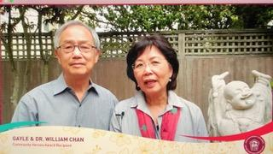
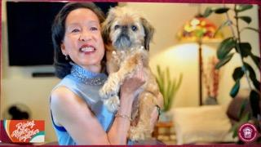
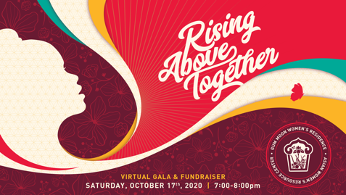
2

The Focus on Cleaning the Environment Continues….. Rotary’s 7th Area of Focus
Picking up trash, painting over graffiti, engaging the community!

District 5150 Polio Plus District Fundraising Update:
I would like to share with you how your contributions impacted our PolioPlus fundraising efforts. You will recall that we had the Polio Summit on October 3rd which was followed up with the Rotary Road Rally on October 24th all to End Polio. Through both events we encouraged people to donate to the PolioPlus Fund to keep the promise to the children for a Polio free world. I am absolutely thrilled to share with you our District’s fundraising efforts. Since July 1 of this year, we have raised $102,586! Wow!!!
In addition, Clubs have donated $6,962 in District Designated Funds (DDF). When adding the matching funds from the World Fund and the Bill and Melinda Gates Foundation, we have raised $349,530 for PolioPlus.
A new record for District 5150! Thank you! Jayne Hulbert PDG

Rotary’s October 9th Blood Drive
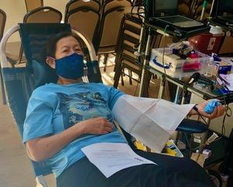
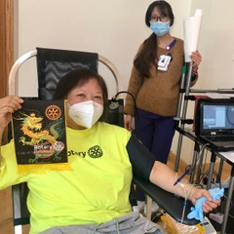
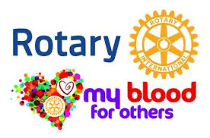

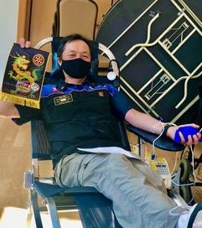

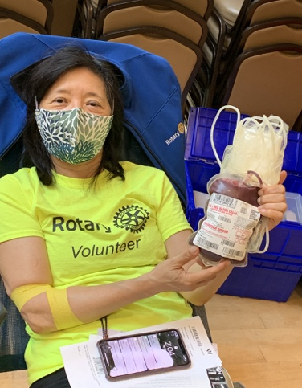
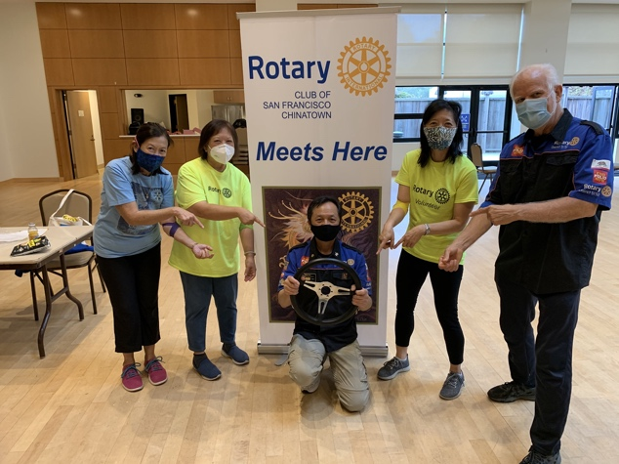

3

Our Club Members Really Stepped Up
to Help Beautify and Clean Our Environment. Our members unite with likeminded community groups to clean the streets of San Francisco
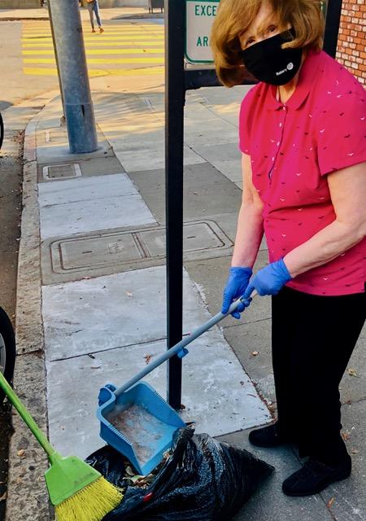
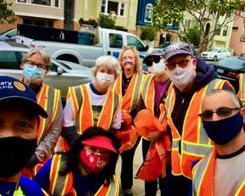
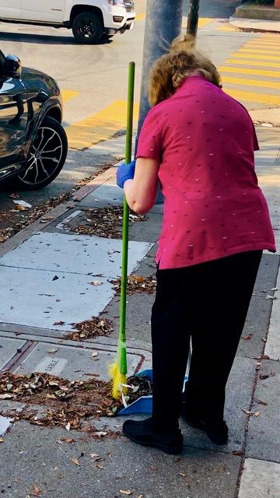

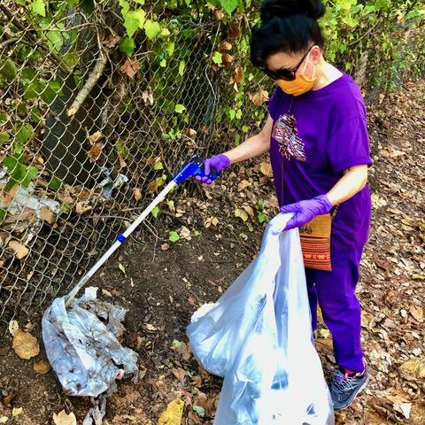
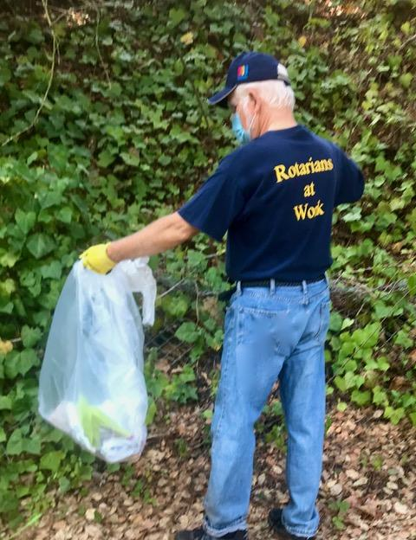
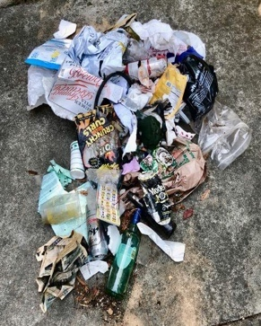
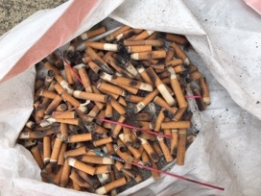

A Reminder: Cameron House Food Pantry continues on….each Thursday they have a Food Pantry 9:30-2:30.
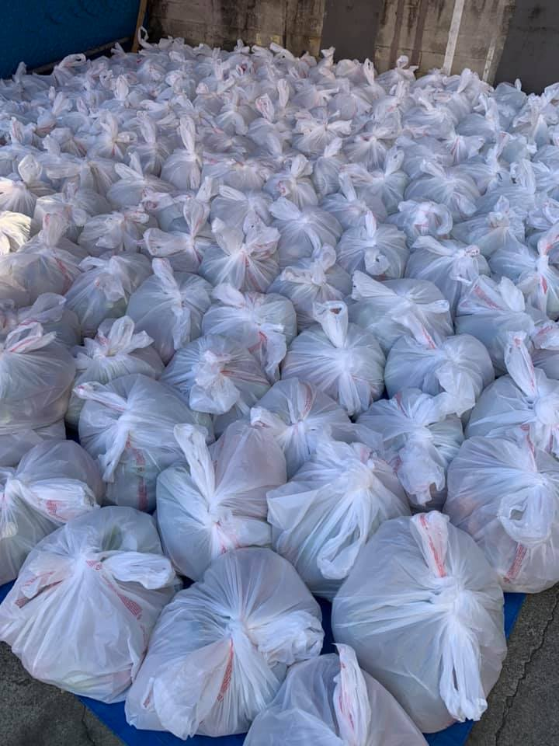
Our Club Members, Liz Mark, Ron Gin and Michael Zheng prepare the food bags seen here for distribution to 250 needy families in the Chinatown SROs.
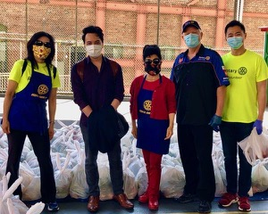

4
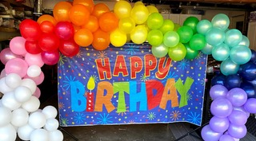

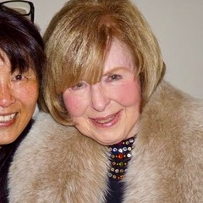
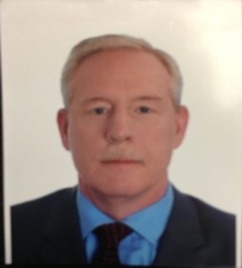
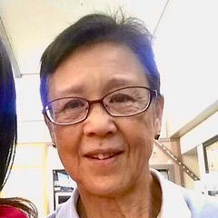

November Birthdays
Junko Low, Tom Moran & Eileen O’Riordan
Happy Birthday to You All!!
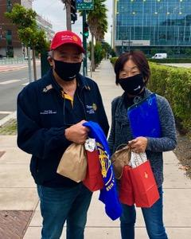
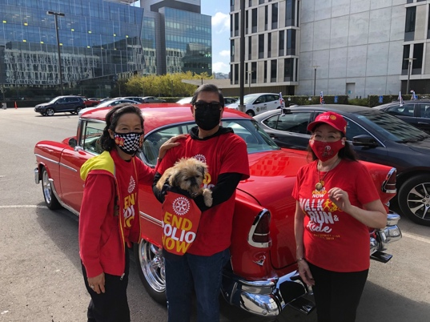
Rotary Road Rally to End Polio Now
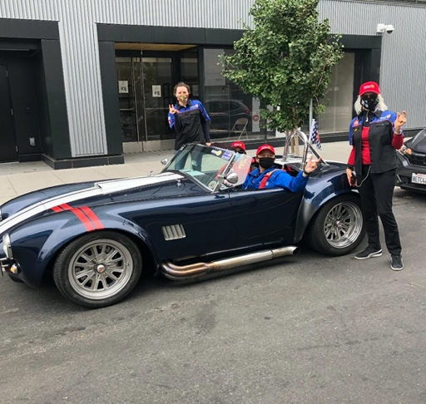

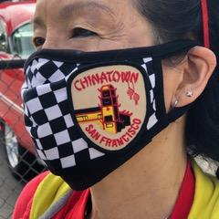
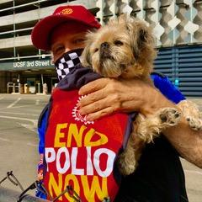
President Paul & Cindy Chin

DG Mary Bates Ron & Liz in their Cobra

Chinatown was there in force!

5
Our Club will have two (2) New Members
Let’s ALL Welcome
Gary Watts & Tom Moran
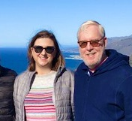
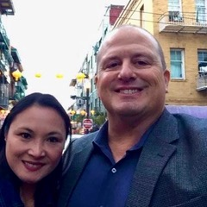

Our Club is happy to welcome back Gary Watts. Gary and his wife Edna live in Walnut Creek. Gary works at Frontier Wealth Strategies, LP in Walnut Creek as a wealth advisor and tax planner. Since we last saw Gary, he has become an Enrolled Agent in addition to being a Certified Financial Planner. His lovely bride of 25 years works at WineBow as a wine portfolio analyst. Their two sons keep growing; Reeve is a junior at Sonoma State University and Gage is a junior at Northgate HS in Walnut Creek. Gary also volunteers for the Civil Air Patrol and is his squadron’s Emergency Services Officer. Gary is delighted to be back with his RCSFC family and is looking forward to seeing everyonel again soon. Welcome Back Gary!

Tom Moran and his wife Leslie recently moved to San Francisco. Tom is a 30 year veteran of the US Foreign Service and has served 10 overseas tours in Europe, Africa, the Middle East, and most recently Tokyo, Japan.
Tom and Leslie have 2 grown children and plan to retire eventually in Capitola, California. Tom was referred by a good friend and fellow Rotarian, Jim Zenner. Tom looks forward to working on Rotary service projects both in the US and abroad. Welcome Tom!

Reminder: RCSFC Foundation Board has a “New Member” As many of you are aware, Mark Czanderna left our club in late September. As a Foundation Board Member, the position was then left open. Stuart Williams has graciously accepted the position. Thank you Stu.
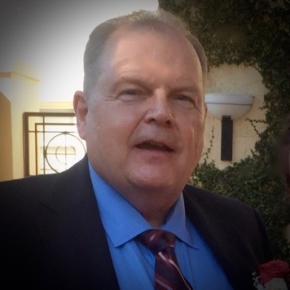
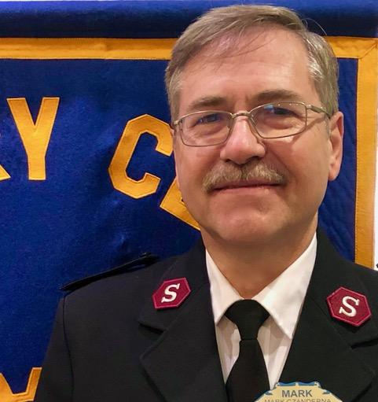

6
Stuart
Mark
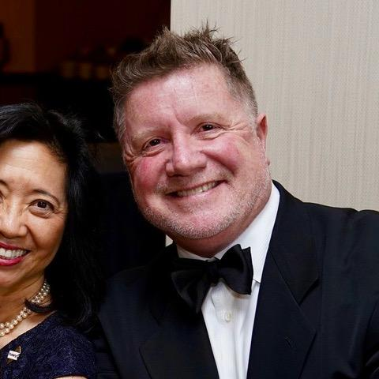
More News! As many of you know our past president, Jeff Oakes celebrated his birthday last month. To honor Jeff, his Mother-in-Law, Mary Ann Sidell has graciously donated $300 in his name, to our Rotary Club. Thank you Ms Sidell and thank you Jeff for your continued support of our Club through your membership.

Mary Ann Sidell wrote, “We would like to make a donation to your Rotary Club in San Francisco in honor of our dear friend and son-in-law Jeffery Oakes”.

News from Bill & Gayle Chan….
Just wanted to share a few photos taken with our 2019 TACT Recipient Terry Zhou and our 2020 Recipient Irene Tan. We have been in touch with Terry to see how she is doing after UC Berkeley went into remote learning in the spring. Terry moved back home in April. We also got together with our 2020 recipient Irene Tan before she headed down to UC San Diego in mid-September. UC San Diego has on-campus learning. We are very happy to report that they both are doing well and staying safe. Here are some pictures:
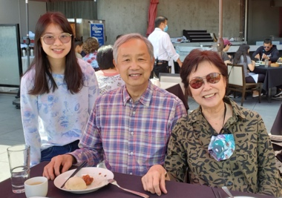
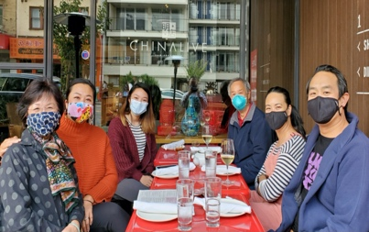
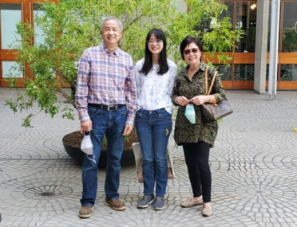
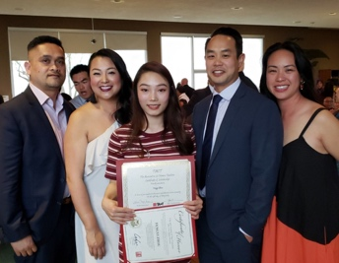

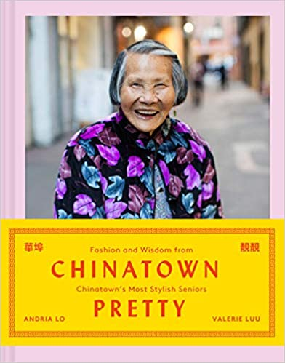
FYI
(This book is currently available on Amazon)
Chinatown Pretty is a signature style worn by pòh pohs (grandmas) and gùng gungs (grandpas) everywhere—but it's also a life philosophy, mixing resourcefulness, creativity, and a knack for finding joy even in difficult circumstances.
• Photos span Chinatowns in San Francisco, Oakland, Los Angeles, Chicago, New York City, and Vancouver.
• The style is a mix of modern and vintage, high and low, handmade and store bought clothing.
• This is a celebration of Chinese American culture, active old-age, and creative style.
Chinatown Pretty shares nuggets of philosophical wisdom and personal stories about immigration and Chinese-American culture. This book is great for anyone looking for advice on how to live to a ripe old age with grace and good humor—and, of course, on how to stay stylish.

7

Rotary’s Six (6) Areas of Focus has been expanded to Seven (7).
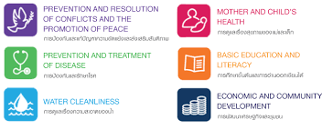

Adding: As the 7th Area of Focus

“Getting To Know You”
As part of the “Getting To Know You” series we would like to showcase one club member in each Newsletter. With the Stay In Place (SIP) and Work From Home (WFH) policies being promoted we all suffer from some degree of social isolation. Many of us, though we have met socially for some time, have not had the opportunity to get to know one another better. I initially asked Paul Chin to step up and send me his brief bio with some pictures. Thank you Paul for stepping up to get the ball rolling and sharing with our club. Our July Newsletter showcased Paul Chin. Our August Newsletter we have had the pleasure to get to know our fellow member Celine Wong. September Susan Tom shared with us a brief history of her growing up in Chinatown, her teaching career, her family and how she found Rotary. Last month we were thankful to have the opportunity to get to know Gayle & Bill Chan.
This month we have the honor to get to know Eileen O’Riordan.

Eileen O’Riordan
I was born in Cork Ireland to 2 wonderful parents Joanna & Michael O’Riordan. One of four children, I had 2 older brothers, Patrick and David; and a younger brother Michael. Growing up with three brothers my parents felt I needed to focus on more “girly things”; dolls, sewing and such.
I soon found that pursuit boring and came to realize my interests were with reading and sports. I enjoyed the competition and would often beat my brothers with my skills in hurling and volleyball.
At eight I took up “Irish Step-Dancing” and enjoyed the physicality of movement whether it was dancing, jump rope or sports. I have fond and vivid memories of our neighborhood families getting together and listening to the sport commentators on radio give their animated blow-by-blow description of the game. I was hooked. I have been a sports fan ever since. A passion I share to this day with Sugo, Vanita, Austin, Rose and many of our members.
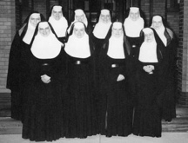
My grade school and high school education was Catholic, run by “The Sisters of Mercy”. At age 16, I was approached by a visiting Priest that was recruiting young women into the Sisters of Mercy Order in Auburn California. I signed up and was on my way to Northern California with 3 other recruits. 8

A year later I was assigned a career in Nursing, and sent off to receive my training @ USF. After I graduated, I was assigned to work at Mercy General in Sacramento primarily in Nurse Management. During that time as a Nurse Manager the concept of Intensive Care Units were evolving. It was so very satisfying to me to see this specialty develop so that those patients that needed a greater depth of care could receive it.

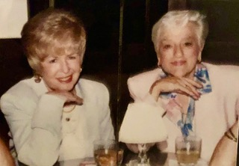
After 16 years I left the order and decided to pursue my Masters in Nursing at UCSF while living at the dorms on campus. It was there that I also attended night school to acquire an MBA.
Upon graduation, I moved into an apartment and met up with Dotty (aka “Spunky”) and it was here that began a 28 year close friendship. Over the years we spent countless hours together traveling to Hawaii, Ireland and going on multiple Cruises around the world. When visiting Ireland to visit my 3 brothers and 10 nieces and nephews, Dotty would accompany me. She was loved by my family. Sadly “Spunky” passed in 2001 and I miss her to this day.
My friend Dotty "Spunky"

In the late 70’s with both my MBA and Masters in Nursing, I was hired as the Director of Education for French Hospital. As Director, I oversaw the education of all the staff in all the departments.

Two year later I was drawn back to UCSF to work on a federally funded project, developing programs and meeting with lawmakers in Sacramento to formulate legislation mandating Continuing Education for nurses. After 3 years the project was completed… I then moved to Los Angeles to work for a CPA/Accounting Firm that evaluated Hospital Operations for efficiency. (It was here in Southern California, that I knew My Heart Belonged in SF/Bay Area!!)
So once Stanford came calling… I answered! They offered me a job as Director of Education for Nurse Managers and I helped to usher in new “computer systems” for staff nurses to do their charting and ordering of supplies.

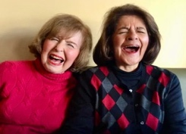
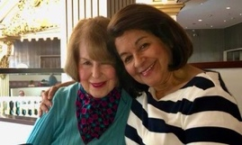
Returning to the Bay Area/SF I moved into the apartment complex where I currently reside. Dotty was alive during that time and lived just across the hall. After her passing, a young lady moved in. Her name was Sandra and we soon became close friends. For years Sandra and I traveled together, and later,taking an Alaskan Cruise celebrating her 60th Birthday. Sandra remained across the hall until 2018. She currently resides in Minnesota with her extended family.
Enjoying a good laugh!
Sandra & I on a Cruise

It was in the late 80’s that I joined a small Consulting Company that specialized in Nursing Computer Systems. Our region covered the entire West Coast and I found myself traveling from Seattle down to San Diego, setting up, consulting and trouble shooting nursing computer systems. It was exciting for the first couple of years.

After 3 years of traveling up and down the West Coast, I settled in as a Director of Nursing Systems at Washington Hospital in Fremont, CA. As Director for 16 years and as a consultant for another eight I shepherded in a distinguished award that only a few hospitals ever attain; the “Magnet Hospital Award” a status that Washington Hospital attained before even Stanford and UCSF had acquired it. It was truly a feather in my cap!

In 2013 I officially retired; and it was shortly thereafter that I met Vanita & Austin. We often frequented a local restaurant and would strike up conversations. As it turns out, we both attended St Ignatius Church where Vanita also taught Sunday School. The conversation soon turned to Rotary and I was invited by Vanita as her guest to meetings.
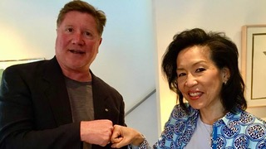
I’ll never forget the warm greeting I received, especially from Jennifer Cheung. I felt very much at home and when I joined in 2014 I was sponsored by Vanita and sworn in by incoming President, Jeff Oakes. I felt that Rotary was a perfect vehicle for me to pursue “Service To Those in Need”. I really feel that the RC of SF Chinatown is like my extended family. With a love of travel, I had a great experience attending a Rotary International Convention in Toronto, Canada in 2018. It gave me a deeper appreciation of what Rotary is about and all the good it does in the world.
Jeff Oates & Vanita Louie

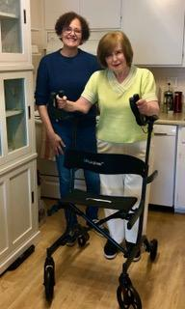
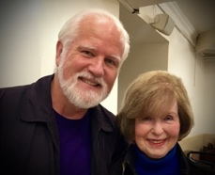
In June 2019 I sustained an ankle fracture that required surgery and rehabilitation that was challenging. It was here that I was truly blessed to find an exceptional caregiver and good friend, Gloria Bustamante. She has been like family to me and when I recently celebrated my 85th Birthday with her, her son and sister, they took me out to brunch. I am forever grateful for their kindness and friendship.

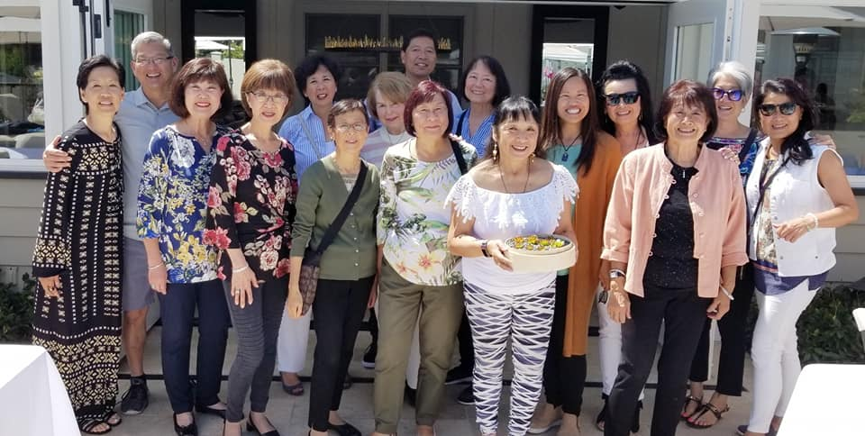
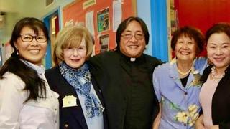
(A shout out to all those members that sent me best wishes on my birthday, and a special thank you to Gloria, Vanita, Rose and Richard for the “upright walker” gift I received. I’m using it every day!) Blessing to you all. May you all remain healthy and safe.
My new "Upright Walker"

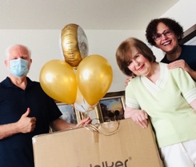

My Chinatown Rotary Extended Family

My Birthday Present Arrived.....

Be well. Be safe. And may gratitude fill your life.

I’ll leave you with this wise suggestion given to us by Moo Moo:

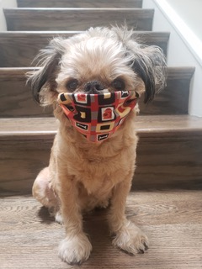

Always remember to wear your mask ………over your nose!?!

10

