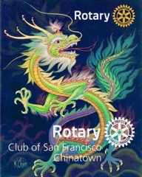
Rotary Club of SF Chinatown
Newsletter
December 2020 vol #6

Welcome members and friends to our Club’s December Newsletter.

RCSFC Fundraising
Our Club Fundraiser is currently being planned with our club’s planning committee. (see names below) This will be a Raffle Drawing scheduled around the Chinese New Year. The CNY is (February 12th 2021) and is the Year of the Ox. Currently, we are planning on both cash & gift baskets as prizes.
We are all open to all of your ideas on this subject.
We are asking each member to purchase tickets that they can then either resell, gift to others (in Red Envelopes) or keep for themselves. We are inviting our members to purchase booklets of tickets totaling $500. All proceeds of this raffle will go to our Club’s Foundation to support our projects and provide both goods and services to those less fortunate in our community and abroad.

RCSFC Fundraising Committee:
Paul Chin Liz Mark Rhonda Pierce Celine Wong Rose Chew Vanita Louie Richard Swart Ron Gin Reagan Lee

Summary of Past November Events:
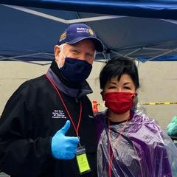
November 13th CCDC SRO Food Packaging and Delivery
(20 lbs of produce gifted to 240 residents of Ping Yuen)

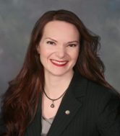
November 14th Top Gov Danielle Lallement DGE
(Virtual Graduation)
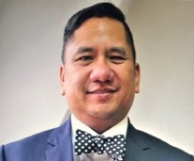

November 18th Club Meeting Speaker: Don Pangilinan
Immigration Attorney

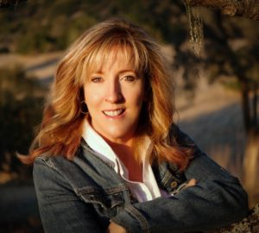
December 2nd Club Assembly (Election of Club Officers)
Guest Speaker : Susan Farren “PTSD”

1

Upcoming Events

See Our Club Website: https://www.sfchinatownrotary.org/weekly-program-speakers
December 12th “Christmas in Chinatown” 11am – 2pm
(Santa (Rich) and Mrs Clause (Miyo) on a Firetruck in Chinatown) (iCafe on Waverly)

December 12th Charter new eClub: “RC for Global Action”
( 10am -12 noon ) No charge but must register for “Zoom Event”. Go to District 5150 Website.

December 16th No Club Meeting

December 18th RCSFC Holiday Virtual Celebration 12-1:30p

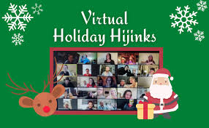

Our Next Club Meeting will be January 6th

Have a Joyful Christmas and a Very Happy New Year

2
Results of Club Elections for 2021-22
(Effective July 1st 2021)
RCSFC Operational Board
President: Rhonda Pierce
Past President: Paul Chin
President Elect: Richard Swart
Secretary: Liz Mark
Treasurer: Reagan Lee
(July 1st , we want to thank Clifford Cheung for his prior services as Treasurer)
4 Directors: Jennifer Cheung, Gary Watts, Celine Wong, Tami Aviles
(July 1st we also want to thank Judy Judkins and Vanita Louie for their prior services as Board Directors.)

RCSFC Foundation Board
(We will have all the same presidential line as above)
Secretary: Junko Low
Treasurer: Cathy Cheung
2 Directors: Stu Williams, Richard Swart
(July 1st 2021 Rich Swart will step down as Director and the Operational Board will choose a replacement.)

Club Service Showcase
((Service above Self. Doing what we can, when we can, where we can, while remaining safe.))
Our club continues to remain active on many fronts. From “hands-on” food distribution & community clean up efforts to virtual learning engagement we are making a difference in the lives of others. The COVID Cloud cannot blanket the efforts of Rotarians! Additionally, our members have been honored and showcased by Gum Moon and the Asian Woman’s Resource Center during their Annual Virtual Gala Fundraiser. Bill and Gayle Chan were honored for their service to the community. Vanita & Moo Moo were highlighted for reading to the young children at two of the Gum Moon preschool daycare centers.
The work continues….SF Firefighters Toy Drive receiving new bicycles (after over 100 were stolen), Cleaning the streets and parks, SF/Marin Food Bank distribution and CCDC drive to feed over 250 families in Ping Yuen with 20 lbs of groceries per family. The work and outpouring of generosity continue even during the most challenging of times.

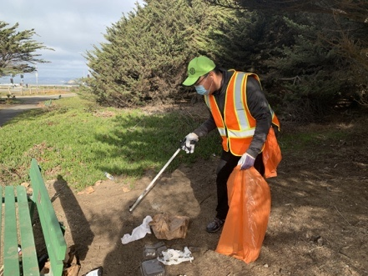
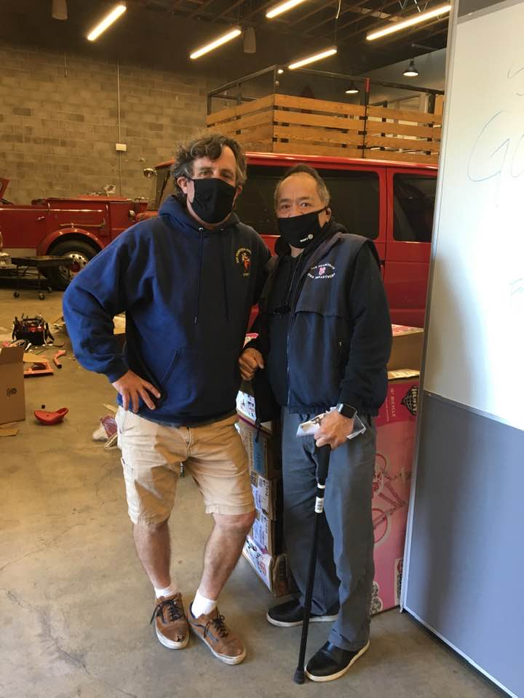
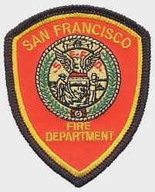
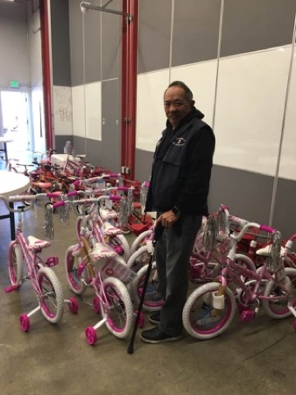

Partnering with SF Rotary Clubs
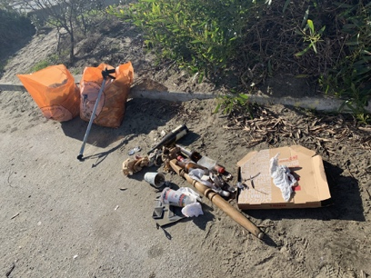
To help clean our environment
Paul Chin and Firefighter both
volunteering at the SFFD
Christmas Bicycle and Toy Drive
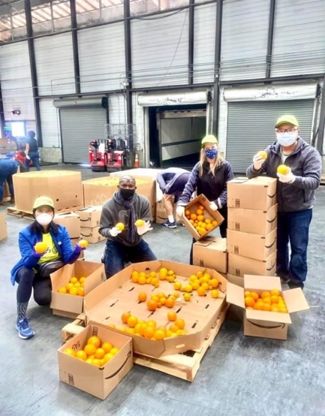
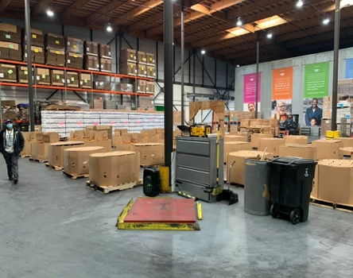
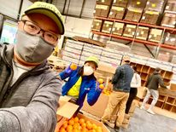

Giant warehouse with boxes to unload
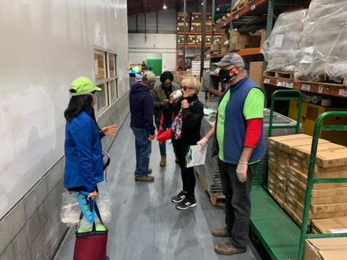
Food Bank with Harry Eng & Liz Mark

RCSFC partners with SF #2 & Castro

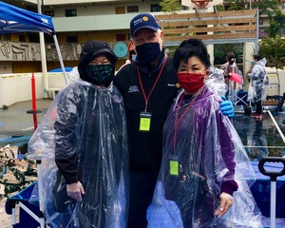
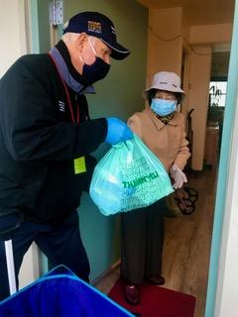
Rotarians organizing efforts

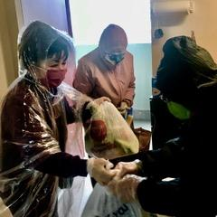
Delivery to their door.

Lily Chan, Rich & Miyoko @ CCDC- Ping Yuen Food Distribution
Miyoko delivering groceries.

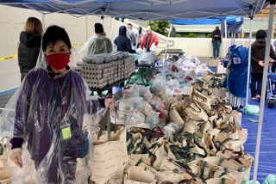

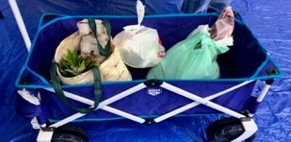

Carts used to carry the 20lbs of groceries
4 bags are placed into each cart

4
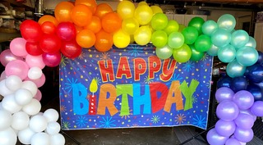
December Birthdays
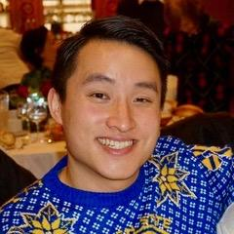
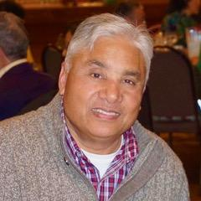
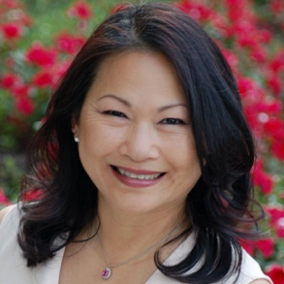
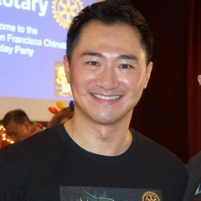
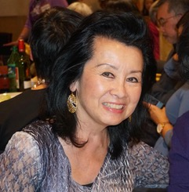
Lily, Michael, Janet, Rajiv & Cliff
Happy December Birthdays to You All!!

5
Again, Let’s All Welcome Our New Members
Gary Watts & Tom Moran
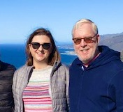
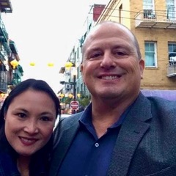

Gary Watts, our club is happy to welcome you back. Gary and his wife Edna live in Walnut Creek. Gary works at Frontier Wealth Strategies, LP in Walnut Creek as a wealth advisor and tax planner. Since we last saw Gary, he has become an Enrolled Agent in addition to being a Certified Financial Planner. His lovely bride of 25 years works at WineBow as a wine portfolio analyst. Their two sons keep growing; Reeve is a junior at Sonoma State University and Gage is a junior at Northgate HS in Walnut Creek. Gary also volunteers for the Civil Air Patrol and is his squadron’s Emergency Services Officer. Gary is delighted to be back with his RCSFC family and is looking forward to seeing everyone again soon!
Update: Gary Watts has just been voted in as a Director on our Club’s Operational Board. We welcome your participation, and our club members look forward to working with you.

Tom Moran and his wife Leslie recently moved to San Francisco. Tom is a 30-year veteran of the US Foreign Service and has served 10 overseas tours in Europe, Africa, the Middle East, and most recently Tokyo, Japan.
Tom and Leslie have 2 grown children and plan to retire eventually in Capitola, California. Tom was referred by a good friend and fellow Rotarian, Jim Zenner.
Update: Tom and Leslie have already volunteered for projects involving neighborhood clean-up. Tom states that he looks forward to working on Rotary service projects both in the US and abroad. Welcome Tom!

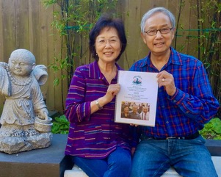
Update on The Edwin and Anita Lee Newcomer School (EALNS)
As this year progresses, we are doing what we can to help support
the incredible staff and the immigrant Chinese students at this school.
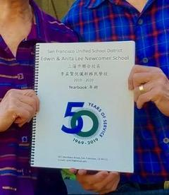
As many of you are aware, Bill and Gayle Chan have funded
the EALNS (CEC) Annual School Yearbook for many years.
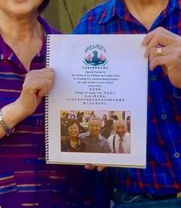
This generous gift has afforded the students a valuable keepsake of both their pivotal and formative time
(12 – 18 months) at EALNS prior to transitioning into the SFUSD System.

Thank You Bill & Gayle.

6
Rotary’s 7th Area of Focus :
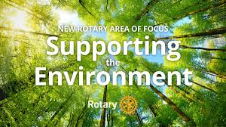

“Getting To Know You”
As part of the “Getting To Know You” series we would like to showcase one club member in each Newsletter. With the Stay In Place (SIP) and Work From Home (WFH) policies being promoted we all suffer from some degree of social isolation. Many of us, though we have met socially for some time, have not had the opportunity to get to know one another better. I initially asked Paul Chin to step up and send me his brief bio with some pictures. Thank you Paul for stepping up to get the ball rolling and sharing with our club. Our July Newsletter showcased Paul Chin. Our August Newsletter we have had the pleasure to get to know our fellow member Celine Wong. September Susan Tom shared with us a brief history of her growing up in Chinatown, her teaching career, her family and how she found Rotary. October we were thankful to have the opportunity to get to know Gayle & Bill Chan, and learn of their children, their travels and how they found Rotary. Last month we got to know Eileen O’Riordan, following her transition from her home in Cork, Ireland to her home here in San Francisco as well as her extensive Nursing Administrative background. This month we have the privilege to get to know more about our Club Member, Liz Mark.

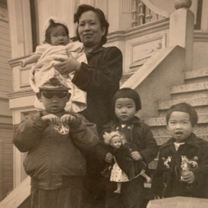
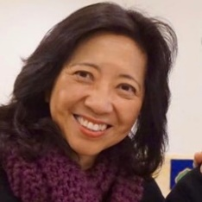
Hi. I’m Liz Mark. I was born in San Francisco into a family with three (3) siblings (with eldest brother Francis, and sisters Carol and Pauline). I grew up attending local public schools. My mother came from Singapore and my father from Malaysia. They were married in Singapore and both traveled to San Francisco as students. Dad was a former Champion Badminton player and taught my sister Pauline and I to play. She and I both competed in many tournaments during our younger days. Mom and Dad both loved music and played the piano, instilling their love of music to the whole family. I later took up the violin briefly during high school but stopped playing before I got married. It was during my high school years that I learned many valuable life lessons and leadership skills while attending Cameron House. And it was at Cameron House that I truly established lasting friendships.
Mom with all 4 of us.
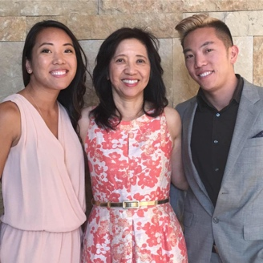
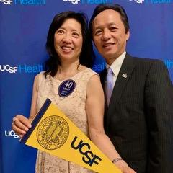
After high school, I went on to attend SF City College and then later transferred to UCSF where I completed my Bachelor of Science in Nursing. Last year I completed a 40 year career in Nursing, retiring from the UCSF Parnassus campus. I am proud of my many years as a nurse that provided me with such a rich and meaningful vocation.
I have two grown children that I am very proud of. My eldest is Jeremy and he is currently a Radiology Technician. My youngest, Cherilyn, is a Family Nurse Practitioner. Both, as you can see, are pursuing careers in the health care field.
Cherilyn and Jeremy
40th year Retirement

7
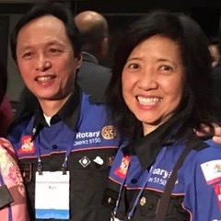
I have been a proud member of the Rotary Club of SF Chinatown since 2012. During that time, I have met and developed lifetime friends while also having opportunities to travel to International Rotary Conventions in Korea, Atlanta, Toronto and Germany. Perhaps the most impactful and gratifying for me have been my trips to India and Guatemala, where we were actively involved in life changing projects. For me, helping to build schools using discarded plastic bottles, donating and sizing “reading glasses” for people, installing both clean water systems and educational wifi units in Guatemalan schools as well as dispensing Polio vaccines and clean water systems in India, has given me a richer and deeper appreciation for what Rotary can do and a profound gratitude for the life I live today.
Proud Rotarian
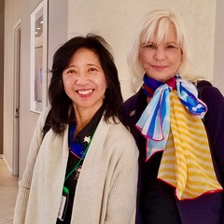
As your Club’s Past President, current Club Secretary and Assistant Governor to the District 5150 under DG Mary Bates, I enjoy remaining active and doing what I can to embrace Rotary’s theme of “Service Above Self”. Outside of Rotary, I am on my 4th year as a Board Member of Cameron House and currently, on Thursday mornings, I volunteer at their Food Pantry, packing 250 bags for needy families.
AG with DG Mary Bates
My current hobbies include Yoga & Pilates, (both virtual) and occasionally, outdoor Tennis and Cycling. Since April, I have chosen to take up violin lesions on Zoom after over 40 years on hiatus. When I came across my old violin it was dusty and in profound disrepair. After a complete overhaul I have taken up the challenge and practice fairly often. As many of you know I lost my dear dog “Angel” a few years back but have just recently adopted “Joey” …weighing just 2 pounds and at 9 weeks old he is so very full of energy!!!!
"Angel"...RIP!
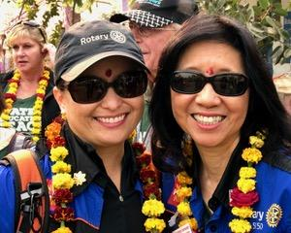
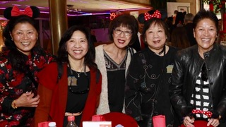
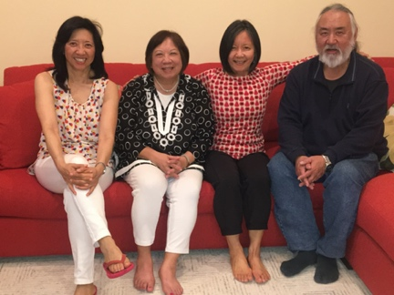
Joey: 6 weeks old

H2Open Doors in India
My Rotary Family Members
Siblings: Pauline, Carol & Francis

2020
For many of us this year was deeply challenging, on many levels. Staying home and not being able to socialize for our safety and the safety of others, has sequestered many of us in self-imposed siloes with our furry companions. It is with their unconditional love and companionship that we salute our furry family and thank them for supporting us through some very rough, ruff-ruff times!

8
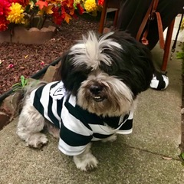
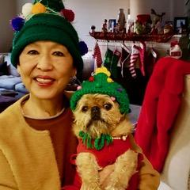
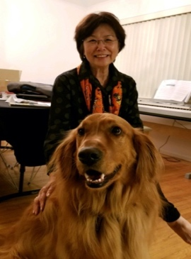
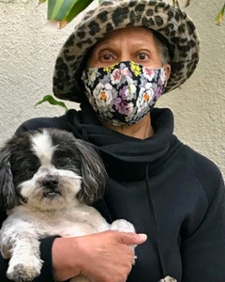

Festive Vanita & "Moo Moo"
Ollie in Prison PJs
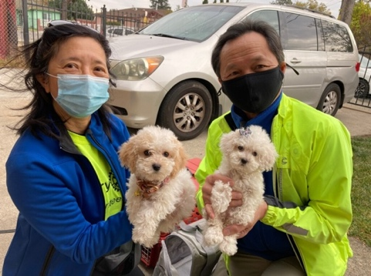
Gayle Son's dog “Tiger”
Judy & “Ollie”
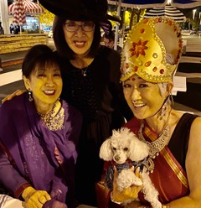
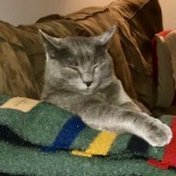

Adoption Day for “Joey” & “Chewy”
Rescue kitty "Smokey"
Helen's "Maile"

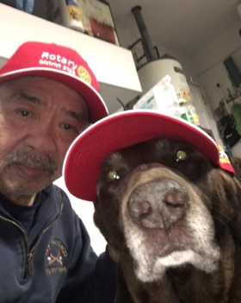
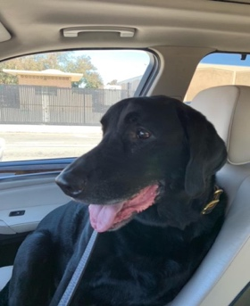
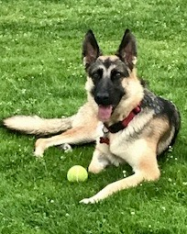
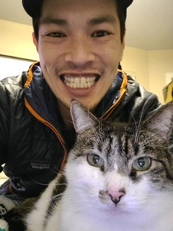

Paul & “Sadie”
Rescue Shepard "Murphy"
Susan’s Son Keith with Cat
Steve Forney's "Driver"
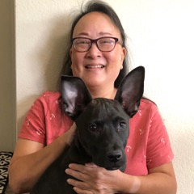
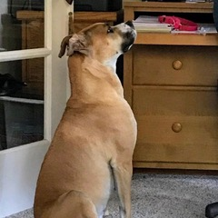
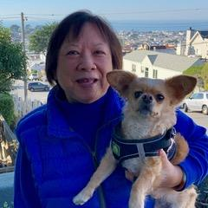

Tami & pal "Hiku”
Pauline & "Yoda"
“ Jack” watching Rajiv

Be Well. Be Safe. And May Gratitude Fill Your Life.
May the joyful spirit of the holidays always dwell deep inside.
May your heart remain full of the love you have for yourself and others.
May this time be a time of reflection and gratitude.
&
May you always be reminded that you are a gift to this world.

9

